Interim Report Summary
November 2019

Royal Commission into
Victoria’s Mental Health System
Interim Report
Summary

Penny Armytage
Chair
Professor Allan Fels AO
Commissioner

Dr Alex Cockram
Commissioner
Professor Bernadette McSherry
Commissioner

ORDER TO BE PUBLISHED
Victorian Government Printer
November 2019
PP 101, Session 2018–2019

Interim Report Summary
Published November 2019
To receive this publication in an accessible format phone 1800 001 134, using the National Relay Service 13 36 77 if required, or email Royal Commission into Victoria’s Mental Health System <contact@rcvmhs.vic.gov.au>
Authorised and published by the Royal Commission into Victoria’s Mental Health System, Melbourne Victoria.
© State of Victoria, Royal Commission into Victoria’s Mental Health System, November 2019.
Except where otherwise indicated, the images in this publication show models and illustrative settings only, and do not necessarily depict actual services, facilities or recipients of services. This publication may contain images of deceased Aboriginal and Torres Strait Islander peoples.
In this document, ‘Aboriginal’ refers to both Aboriginal and Torres Strait Islander people. ‘Indigenous’ or ‘Koori/Koorie’ is retained when part of the title of a report, program or quotation.
ISBN 978-1-925789-43-0 (pdf/online/MS word)
Available at the Royal Commission into Victoria’s Mental Health System website <https://www.rcvmhs.vic.gov.au>
ISBN 978-1-925789-43-0
Suggested citation: State of Victoria, Royal Commission into Victoria’s Mental Health System, Interim Report Summary, Parl Paper No. 101 (2018–19)

Contents
Summary 5
The Royal Commission 5
What the Commission has heard 6
Context for reform 7
Current state of the mental health system 8
Major themes so far 9
Immediate action and ongoing work 14
What happens next 17
Endnotes for Summary 18
Recommendations 20
Victorian Collaborative Centre for Mental Health and Wellbeing 20
Targeted acute mental health service expansion 20
Suicide prevention 21
Aboriginal social and emotional wellbeing 21
A service designed and delivered by people with lived experience 22
Lived experience workforces 22
Workforce readiness 22
New approach for mental health investment 23
The Mental Health Implementation Office 23

Summary
Most people living in Victoria will be affected by mental illness at some point in their lives, either directly or indirectly. This means that most people will be in contact with the mental health system in some way—directly or through a friend or family member or someone else they know or love.
Poor mental health has become a pressing yet ignored health crisis. Mental health services continue to fail to provide treatment, care and support to people living with mental illness, their families and carers when and where it would offer the greatest benefit.
This has been reaffirmed to the Commission time and time again.
Victoria’s mental health system has been described by the Premier, the Hon. Daniel Andrews MP, by many inside and outside the system, and by countless people living with mental illness, families and carers as ‘broken’. This Royal Commission was called as an acknowledgement of the scale of the problem.
From the Commission’s work so far, it is already obvious that transformational change is required if we are to redesign the mental health system to meet the needs and expectations of people living with mental illness and their families and carers. This Commission was established to develop recommendations for effecting this change.
This is the Commission’s interim report. The recommendations contained in it focus on preparing the way for a new approach to mental health and responding to some of the most immediate challenges. The majority of the Commission’s recommendations for change will appear in the final report, due in October 2020. They will propose major system redesign.

The Royal Commission
A Royal Commission is an administrative inquiry established at the discretion of the Executive Government. It operates independently of government and is granted extensive legal powers. In Victoria such a commission is established by letters patent signed by the Governor and the Premier; it is required to inquire into a specified matter and report its findings to the Executive.
The establishment of a Royal Commission reflects the gravity of the matter the Commission is called on to examine. This is the highest and most consequential form of independent public inquiry, and it is accompanied by a degree of formality, significant powers of investigation and the ability to compel evidence if necessary. Evidence at hearings is given under oath. A Royal Commission usually provides policy advice in its recommendations to government.
The Royal Commission into Victoria’s Mental Health System has been tasked with reporting to the Victorian Government on how the state’s mental health system can most effectively prevent mental illness and deliver treatment, care and support to those living with mental illness, their families and carers. It was not established to make any findings in relation to the conduct of service providers in individual cases.
In meeting and respecting its formal requirements, the Commission has endeavoured to ensure that it has remained as accessible as possible and, in particular, has acted to ensure the dignity, wellbeing and safety of all those who have had dealings with it.

What the Commission has heard
Meaningful and lasting changes to Victoria’s mental health system can happen only if the views of people living with mental illness, their families and carers are listened to and respected.
Many people’s experiences of how the system fails and even harms those living with mental illness have been difficult to hear. They are infinitely more difficult to live through and share. It takes considerable strength to contribute painful experiences to a Royal Commission.
People have told of experiences that suggest the system has reached a point where it simply cannot help those who turn to it—let alone those in crisis. There is an inherent inequity in this when compared with the rest of the health system. One parent shared:
I have a son who has had leukemia, and now a daughter with a mental health challenge. When my son was diagnosed with leukemia, we were immediately connected into an incredible amount of support and services, including those outside the hospital. Our experience when my daughter’s mental illness was diagnosed was completely the opposite.
The Commission heard from people living with mental illness, their families and carers, workers, advocates, administrators and academics. There has been much interest in the Commission’s work; it has received a vast range and amount of evidence through a variety of avenues—community consultations, formal hearings, written submissions and comments, targeted consultations, government documents, and extensive research and analysis.
The Commission received more than 8,200 contributions (including 3,267 formal submissions) and held 19 days of hearings (with 99 individual witnesses) and 22 days of community consultations (attended by 1,650 people). Just over half of the 61 community consultation sessions were held in rural and regional Victoria. Formal hearings were held at the Town Hall in Melbourne, in Maryborough and at the Aborigines Advancement League in Thornbury. There were also a series of roundtables focused on particular topics comprising a range of individuals, among them people with lived experience and representatives of the workforce, providers of services, peak bodies and advocacy bodies, research institutes and universities.
The Commission is not seeking formal submissions on the interim report. Contributions from people living with mental illness, families and carers will continue to be central to the Commission’s ongoing work, and the Commission’s intended process will be further communicated on its website.
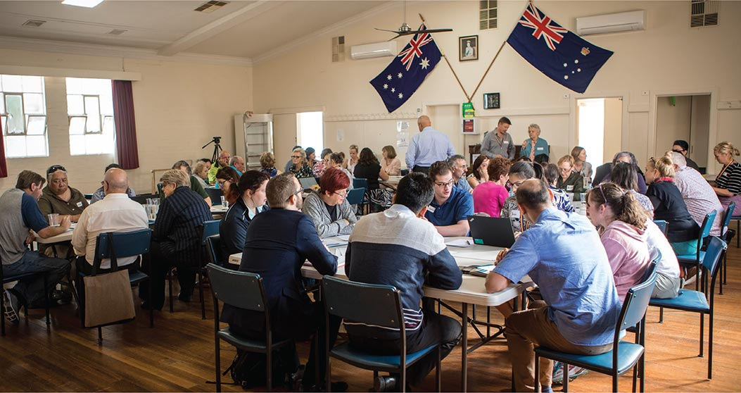
Community consultation, Whittlesea

Context for reform
Each year around one in five Victorians will experience mental illness. Almost half of the state’s population will experience mental illness over the course of their lifetime. It is estimated that 3.1 per cent of people living in Victoria live with a severe mental illness such as schizophrenia or bipolar disorder.
In 2018 there were 720 suicide deaths in Victoria—more than three times the road toll. Ten times as many were admitted to hospital because of self-harm. The extent of suicidal behaviour is alarmingly high among young people.
The human multiplier of mental illness—the additional impact on families and carers, friends, colleagues and acquaintances—is profound. One person living with mental illness told the Commission, ‘You say mental health affects one in five. If you have one person with mental illness in a family of five, that affects everyone in that family’.
These figures, although startling, are not new. They are representative of experiences not just in Victoria but throughout Australia. Mental illness and ‘injury’ from suicide or self-harm contribute significantly to the ‘burden of disease’ in Australia, being eclipsed only by cancer. The data are indicative of a range of challenges that call for a far-reaching response by governments and communities.
It has taken too long to recognise the urgency with which the mental health system’s failures must be confronted. The system has simply not kept up with the changes in the diversity and extent of the demands now placed on it. At one level, this means many people cannot get the services they seek; at the extreme, it places some at risk of a variety of harmful, even fatal, consequences. The Commission has also heard of dehumanising and harmful practices experienced by some people who have been treated within mental health services, as well as occupational health and safety issues.
The Commission has been granted a rare opportunity to make recommendations to reform the system. Although it cannot resolve all the problems that have been brought to its attention, it can, and must, redress the structural deficiencies in the system. This interim report represents the beginning of that process.
Some of the recommendations in this report are aimed at specific, immediate deficiencies. Others will set the foundations for enduring structural reform. The Commission’s final report will deal with the broader changes needed to transform the state’s mental health system.
At present the system is not responding adequately to increasing demand and changing needs and community expectations. Some would argue it is not even working as a ‘system’ but has become nothing more than a collection of poorly integrated services.
The Letters Patent for this Royal Commission are broad and allow for the exploration of a range of influences on the system.
The Commission is not just looking into how the current system operates: just as important is probing the demographic features, social determinants and emerging trends influencing the mental health of all Victorians. The way in which a mental health system connects with other systems and services—such as those involved in housing, disability, education, alcohol and other drugs, family violence, health, justice and employment services—is crucial to determining how that system can best serve the interests of those who use and work in it.
Victoria is changing rapidly in terms of overall population, where and how people live, ageing and socio-economic characteristics. Pressures on housing, urbanisation (both metropolitan and regional) and access to other health services influence the demands on the mental health system. Economic disadvantage has long been a central determinant of a person’s mental health. Homelessness, social isolation and the use of methamphetamines, or ‘ice’, and other drugs are all part of the equation. Still emerging is the influence, both for good and for bad, of social media and new technologies.
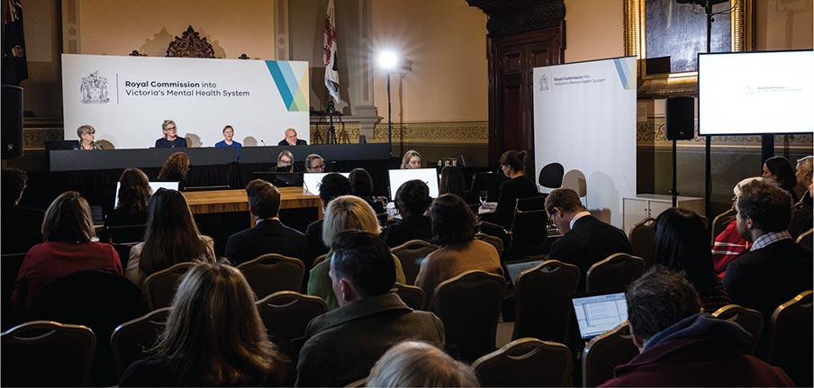
Public hearings, Melbourne Town Hall
Importantly, as Victorians, we all bear some responsibility for the system’s failings. Inclusive, tolerant and supportive communities play a vital role in nurturing good mental health and wellbeing, yet it is evident that stigma and discrimination persist.
The Victorian Government has acknowledged that there must be radical change. It has made a commitment to implement all the Commission’s recommendations. The Premier has said the changes required might come at a substantial financial cost.
There is already much interest, at both the state and territory and Commonwealth Government levels, in the extent of the problems with mental health services in Australia. This Royal Commission’s work coincides with a range of public policy work by the Productivity Commission, the Council of Australian Governments and the Prime Minister’s National Suicide Prevention Adviser. There is also an encouraging level of public interest, discussion and debate in connection with mental illness. It is now more openly talked about in schools, workplaces, social settings and the media, although this is far from consistent when it comes to the continuum of mental illness.
The Commission has a mandate to fundamentally redesign the system, and this complex task will continue to be the focus of its work in the coming 12 months.

Current state of the mental health system
The present state of Victoria’s mental health system can be linked to the system’s origins, structural characteristics, inadequate funding, a lack of planning and the level of demand under which it now operates. It has become a system reactive to crisis rather than a system simply in crisis.
There was a period when Victoria was considered a leader in mental health services. That time has passed. This Commission provides an opportunity for Victoria to provide leadership again.
Mental health services in the state were designed in the 19th and 20th centuries mainly to care for people living with severe mental illness. The system was not equipped to deal with the broader range of people experiencing mental illness and psychological distress or the extent of the demands being made of it in the 21st century.
Since the last major reform to the state’s mental health services, in the 1990s, the system has progressively become more fragmented and more complex. It is beset by blurred service delivery and funding roles and responsibilities, inadequate systemic and statewide planning, and poorly allocated funding. It has drifted away from the philosophy that underpinned its last major reformation.
That philosophy was based on a model of ‘stepped care’, with non-residential clinical services in the community and a focus on stabilising acute illness, preventing or managing relapses and supporting recovery. It involved mobile 24-hour crisis assessment and treatment services, services offering long-term support in the community, and clinical and consultancy services. There has since been a move away from this emphasis to a now heavy dependence on emergency departments. This has been a response to demand and funding pressures.
Despite previous reviews by the Victorian Auditor-General and the Victorian Ombudsman, along with efforts by government and others to reframe mental health services, the case for broader reform remains evident. The Productivity Commission recently pointed to this need throughout Australia, saying it would not be a ‘quick fix’.
Mental health services in Victoria revolve around four different levels of treatment, care and support, generally based on the level of and type of need:
- primary care services—for example, GPs and counsellors
- community support and clinical services—for example, private hospitals, public and private psychiatrists and allied mental health services
- public specialist clinical mental health services—for example, acute mental health beds and community-based clinical mental health services
- emergency mental health services—for example, emergency departments and the police and ambulance services.
Individual parts of the system are intended to meet a variety of mental health needs and at differing levels. For many, if not most people, their interaction with the system will be at the level of primary care; those living with severe mental illness will require specialist clinical mental health services.
A greater understanding of the social and economic impacts associated with anxiety disorders and depression has also seen governments, both state and territory and Commonwealth, invest in mental health promotion, illness prevention and primary mental health care.

Major themes so far
Some important themes have emerged in the Commission’s work so far, and these will influence its continuing work and the preparation of its final report in 2020. Some of the themes focus on the system itself; some focus on people’s experiences of trying to find a path through the system.
- Investment in the system is poor. Victoria’s monetary investment in mental health is low compared with the rest of Australia. There is grossly disproportionate investment in mental health compared with physical health. The Commission estimates that the cost of poor mental health to Victoria is $14.2 billion a year, and the burden of this is not shared equitably. The potential economic benefits accruing from investing in improved mental health are clear and are explored in this interim report. Money is one measure, but there is a profound human toll that accompanies a broken system.
- Getting help is difficult. Not being able to find or gain access to services has been a common theme for people living with mental illness and their families and carers. People cannot get suitable support, and those who do gain access to ‘the system’ find it hard to negotiate their way through it. Even people who work in other parts of the health system find mental health services difficult and confusing to navigate. People living with mental illness are waiting longer and becoming sicker before they can gain access to services: increasingly, a person must exhibit signs of major distress or crisis before treatment, care and support become available. Mental health services are seeing people with higher levels of need, clinical acuity and complexity. Many people living with severe mental illness—an estimated 105,000 people in Victoria—are not receiving specialist care (see Figure 1).
- Access to services is not egalitarian. Poverty and disadvantage make it even harder for people to gain access to services. A disproportionate number of people living with mental illness have low incomes and no private health insurance. For many, access to primary care (for example, through a GP) is becoming harder to afford. Further, where people live dictates how easy it is to gain access to services, and this situation can be exacerbated in rural and regional areas.
- The ‘missing middle’ miss out. There is a marked gap in service provision. A large and growing group of people have mental illnesses that are too complex, too severe and/or too enduring to be treated through primary care alone but are not ill enough to meet the strict criteria for entry into specialist mental health services. Their care needs are either insufficiently met or not met at all.
- Emergency departments as entry points of care. System complexity, navigation difficulties and a lack of accessible, appropriate services mean that people are unable to obtain the right support when they need it. Lack of appropriate community-based mental health services has led to disproportionate growth in mental health presentations to emergency departments (see Figure 2).
- Dignity is often disregarded. Many people who do obtain mental health services say they are not treated with dignity or respect and are not involved in making decisions about their own treatment, care and support. Initial contact with the system, especially for those in crisis, can itself be damaging. It can come in the form of intervention by the police or other emergency services workers. The Commission has often heard that flaws in the system can cause even more harm and trauma for the person concerned.
- Stigma and discrimination are ever-present. Stigmatising attitudes and discriminatory behaviours exclude people with mental illness socially and economically, with profoundly negative effects. Stigma towards people living with mental illness is much like racism and other forms of prejudice. Its existence can prevent people seeking help, compound social isolation and loneliness, and can be a barrier to gaining and retaining employment.
- Our younger people are adversely affected. Younger people can experience mental illness at a crucial life stage, as they seek to participate in education and employment, form relationships and set out on the journey of adult life. It is estimated that 75 per cent of all lifetime cases of anxiety, mood, impulse-control and substance use disorders emerge by the age of 24 years. There is a compelling case for greater investment in and attention to the mental health of children and young people.
- Families and carers are left out. There are about 58,000 Victorians who care for someone living with mental illness. Although they are central to these people’s ongoing care, families and carers are often left out of decision making for a complex set of reasons. Being a carer is challenging, and its impacts can be profound and lifelong. There is a general lack of support available to families and carers.
- Mental illness is even more complex for some groups. Additional factors shape the experiences of some people living with mental illness, among them Aboriginal people, LGBTIQ+ people, refugees, asylum seekers, people from culturally and linguistically diverse backgrounds, and people living in rural and regional Victoria. They face a range of barriers when seeking treatment, care and support.
- The mental health of Aboriginal communities. Aboriginal communities continue to live with the effects of trauma wrought by colonisation and post-invasion government activity. Everyday stresses associated with deprivation and social marginalisation can have pervasive negative effects on mental health. Victorian data suggest that the prevalence of depression and anxiety is greater among Aboriginal people compared with non-Aboriginal Victorians (see Figure 3).
- Suicide. Suicide, with its profound impacts on individuals, families, friends and communities, is perhaps the ultimate expression of the failure of the Victorian mental health system. Lack of adequate access to mental health services is contributing to Victoria’s suicide rate.
- Recovery. For many people, the prospect of recovery from mental illness is strong, depending on their personal experience and the extent to which they have been able to obtain treatment, care and support. Putting recovery at the centre of mental health services is essential if consumers are to resume a life in which their full potential and contribution are realised.
- Trauma is unseen. The close relationship between trauma and mental illness and the need for trauma-informed mental health treatment, care and support are starting to be recognised, but there is much work to be done. Many inquiry participants told of the need for a system that is more responsive to trauma and the potential of consumers to be retraumatised. A failing system can itself be the source of trauma.
- The system is driven by crisis. Limited service availability means that many people living with mental illness receive treatment, care and support only at times of crisis. This has led to a risk-averse model of care in which people do not receive therapeutic and psychosocial supports and do not receive support early enough to aid recovery or to avoid an escalation in their illness.
- Demand has overtaken capacity. The system is overwhelmed and cannot keep up with the number of people who need treatment, care and support. This is evident at all levels, from primary care to acute and emergency services.
- Integrated services are lacking. People living with mental illness and other co-occurring conditions such as poor physical health, disability or alcohol and drug misuse can have even greater difficulty gaining access to specialist services that are not sufficiently integrated to respond to various needs.
- Prevention. Beyond the clinical care system, prevention of mental illness is closely linked to broader social and economic factors such as those that help build individual and community resilience. The notion of taking a systems approach to building good mental health, rather than just responding to mental illness, emerged frequently in the evidence the Commission has received. Many social determinants shape mental health.
- It is different outside Melbourne and in the bush. People living in rural and regional areas can face additional challenges, among them stigma and difficulties with access to services. Although in general the prevalence of mental illness is the same as in metropolitan Melbourne, suicide rates are higher in rural and regional Victoria.
- Alcohol and other drugs add another dimension. Increases in the use of alcohol and other drugs—especially methamphetamines—are placing greater demands on mental health services. There is potential for better integration between alcohol and other drug services and mental health services, and for improvements that favour a more holistic approach to treatment, care and support.
- The workforce. The mental health workforce is diverse but there are serious shortages, which are more pronounced in some specialities and in rural and regional areas. Despite their commitment and competence, many workers struggle to perform optimally in a system that constrains them. The value of lived experience work is being recognised; there is great potential to expand and better support these workforces.
The evidence and themes the Commission has explored make it very clear that a redesigned mental health system is needed.
Figure 1: Estimated number of people requiring but not receiving specialist clinical mental health services, Victoria 2019
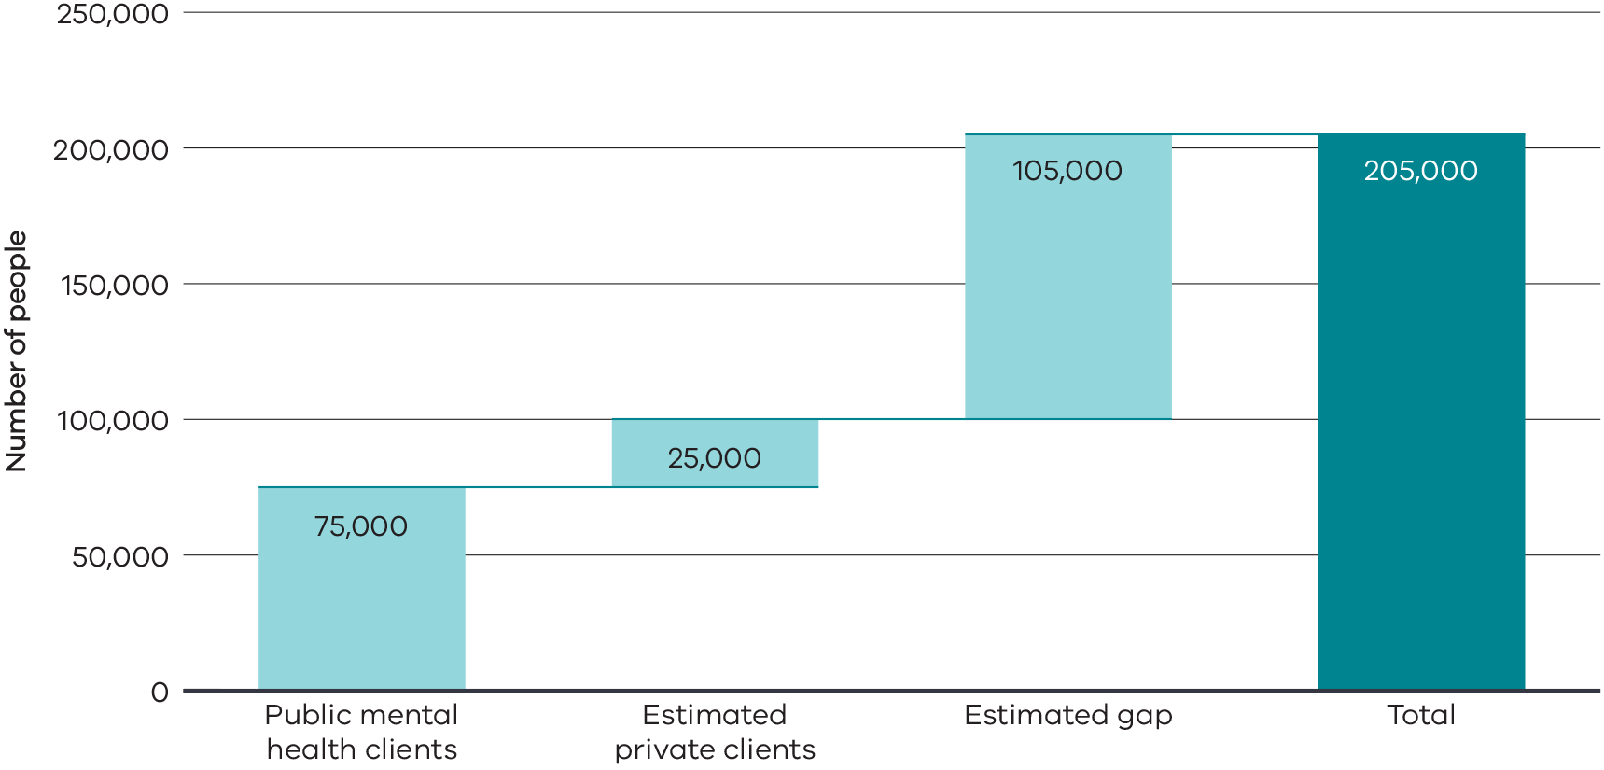
Source: Calculation by the Commission based on National Mental Health Service Planning Framework; Department of Environment, Land, Water and Planning. Victoria in the Future 2019; Department of Health and Human Services, Victoria’s Mental Health Services Annual Report 2018–19, 2019, p. 82; Australian Institute of Health and Welfare. Mental Health Services in Australia. Overnight Admitted Mental Health-Related Care 2017–18. Table ON.4 and Same day admitted mental health-related care 2017–18. Table SD.4 and SD.12 <https://www.aihw.gov.au/reports/mental-health-services/mental-health-services-in-australia/report-contents/summary-of-mental-health-services-in-australia> [accessed 9 October 2019].
Note: The estimated number of private clients using the private system is based on the statewide proportion of overall mental health admissions in Victoria that occur in private hospitals. Utilisation of private mental health services in rural and regional areas may differ from the state average. There may also be clients receiving care in both public and private specialist services that are double counted. There may also be people receiving specialist mental health services from other private providers that are not counted with this methodology.
Figure 2: Change in the number of emergency department presentations, by mental health status, Victoria 2008-09 to 2017-18
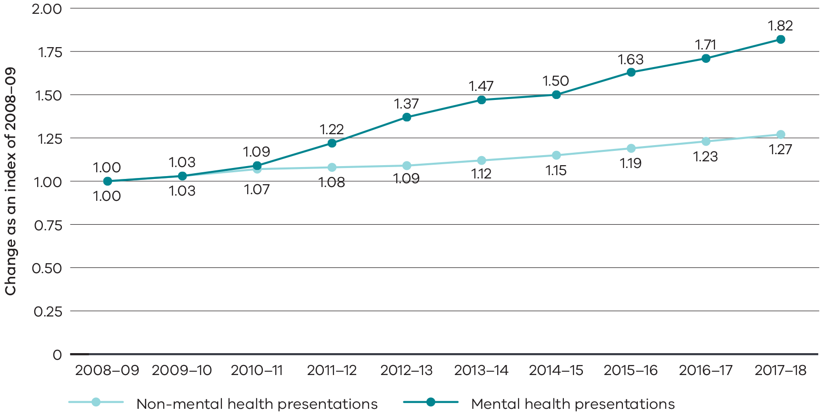
Source: Department of Health and Human Services. Integrated Data Resource, Victorian Emergency Minimum Dataset 2008–09 to 2017–18.
Note: Mental health-related emergency department presentation defined as: a) the presentation resulted in an admission to a mental health bed (inpatient or residential), OR b) the presentation received a mental health-related diagnosis (‘F’ codes, or selected ‘R’ and ‘Z’ codes R410, R418, R443, R455, R4581, Z046, Z590, Z609, Z630, Z658, Z765), OR c) the presentation was defined to be ‘Intentional self-harm’, OR d) the presentation involved interaction with a mental health practitioner.
Figure 3: Proportion of adult population ever diagnosed with anxiety or depression, or with high/very high levels of psychological distress in the past four weeks by Aboriginal status, 2017
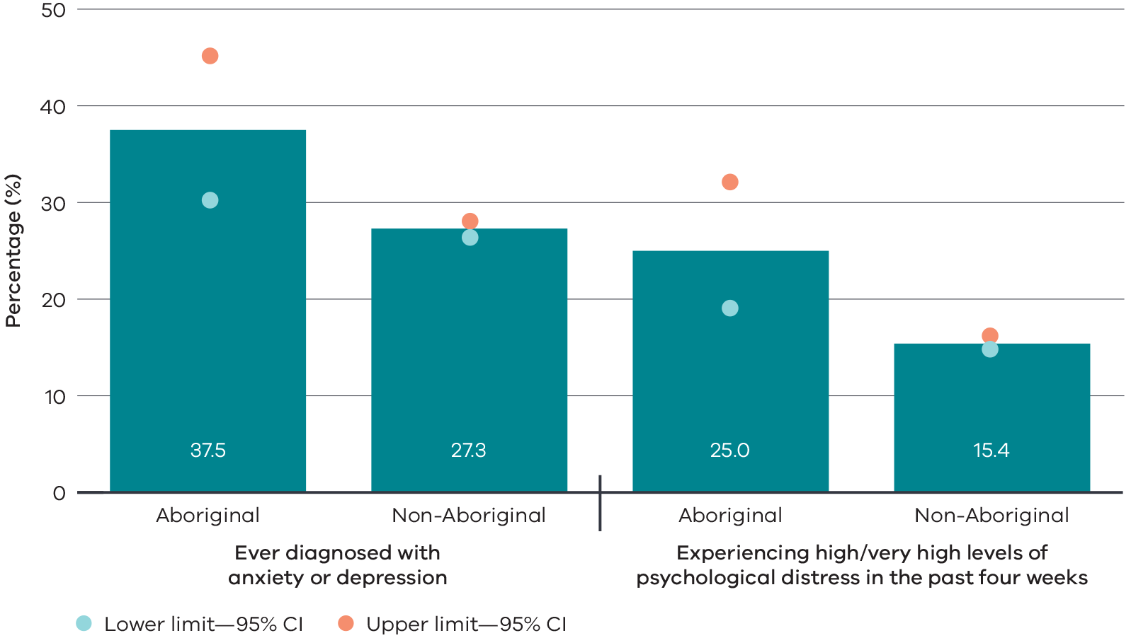
Source: Victorian Agency for Health Information, Mental Health and Wellbeing – Victorian Population Health Survey 2017 (preliminary draft and unpublished).
Notes:
- Data is age-standardised to the 2011 Victorian population.
- Lower limit/Upper limit is the 95 per cent confidence interval lower and upper limits.
- Psychological distress based on the Kessler 10 scale.

Immediate action and ongoing work
Although its work is barely at its halfway point, the Commission has determined that the following matters require immediate action:
- a new approach to funding, comprising a new revenue mechanism to enable a substantially increased investment in mental health. This will facilitate delivery of the reforms required to establish a contemporary and enduring mental health system
- the creation of the Victorian Collaborative Centre for Mental Health and Wellbeing to bring together expertise in lived experience, research and clinical and non-clinical care, disseminating the practice of evidence-informed treatment, care and support across the state
- an additional 170 acute mental health beds for young people and adults in areas of need to help respond to demand
- funding all area mental health services to offer the Hospital Outreach Post-suicidal Engagement program to expand follow-up care and support for people after a suicide attempt, along with the creation, delivery and evaluation of the first phase of a new assertive outreach and follow-up care service for children and young people who have self-harmed or who are at risk of suicide
- the creation of an Aboriginal Social and Emotional Wellbeing Centre and the establishment of social and emotional wellbeing teams in Aboriginal communities throughout the state to support appropriate models of care
- the establishment of Victoria’s first residential mental health service designed and delivered by people with lived experience of mental illness
- the development and implementation of supports and structures designed to enhance and expand consumer and family-carer lived experience workforces in the mental health system
- increased opportunities to expand and develop the workforce—including funded graduate positions, postgraduate scholarships and psychiatry rotations, supported overseas recruitment, leadership development and improved data.
To begin the transition to a redesigned mental health system, the Commission proposes the creation of a Mental Health Implementation Office that will operate for two years to respond to the interim report’s recommendations while the Commission designs governance arrangements for the mental health system.
Box 1
Aunty Nellie Flagg
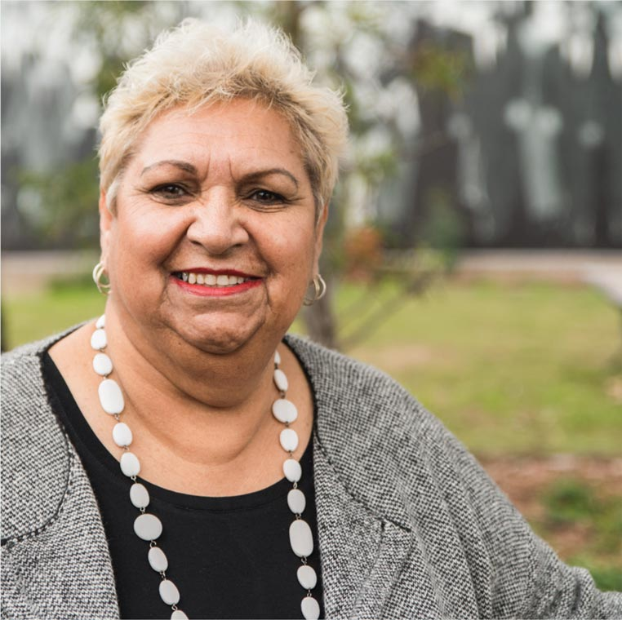
Aunty Nellie Flagg is an Elder and a Taylor-Charles, whose traditional countries are Wemba Wemba, Dja Dja Wurrung and Boonwurrung. She was born in 1957 and grew up as the second-last of ten children.
My life growing up was one of joy, but also a lot of racism that impacted on me, my family and the Aboriginal community.
Aunty Nellie told the Commission about the impacts of racism, recalling times she wasn’t served in shops and when other girls at school would talk to her on the sports field but ignore her elsewhere.
I believe that they did not see me as Nellie; they see me as an Aboriginal person.
She also talked about the impact of trauma and loss on her and others in the Aboriginal community and said that often the trauma comes from family stories, including experiences of death or abuse, which can have a significant impact.
When her son tried to take his own life, he found an Aboriginal counsellor who made a difference.
He didn’t have to explain his culture; the Aboriginal counsellor made him feel at ease because he understood where my son was coming from.
As part of her work with government and community organisations and in Aboriginal Affairs for more than 40 years, Aunty Nellie worked as a suicide prevention worker in an Aboriginal social and emotional wellbeing team.
A lot of our young people die by suicide because of the traumas that they have felt or were dealing with. It was heartbreaking to hear these stories and see the impact with the communities.
For Aunty Nellie, trauma and loss in her own family led her to experiencing depression. She also recognises the effect of hearing other people’s stories as part of her work.
I walked this journey with the people who told me about these things. This affects me and my mental health because I am living not only with my own traumas, but also with other people’s traumas.
When talking about challenges with the mental health system, Aunty Nellie states the importance of access to culturally sensitive services, and also the way Aboriginal people talk about their health and labels.
When Aboriginal people talk about out health, we don’t do it in isolation. Mental, physical and spiritual health is holistic.
Non-Aboriginal people who work with Aboriginal people should receive ongoing cultural training (not just a one-off tick a box). Many Aboriginal people will be more likely to seek the help they need if the person who is helping them understands where they are coming from.
My family has been afraid of people judging them for their mental health issues. They have been afraid to talk about it for fear of being labelled ‘mental’ or being unable to hold a job.
For future services, Aunty Nellie recognises that more funding is needed and should focus on young people and education. She also refers to more needing to be done to address family violence and drug and alcohol abuse and wants more Aboriginal people to share their stories.
… I continue to talk hoping that other Aboriginal people, women and men, are able to talk about what is hurting them.

What happens next
The Commission’s work to date confirms that Victoria’s mental health system is not just compromised—it is afflicted by systemic failings. Although this interim report makes a limited number of recommendations relating to some immediate requirements, the Commission’s focus is on foundational work for system-wide reform and responding to immediate pressures.
Much remains to be done. Fundamental redesign of the system is warranted, and people with lived experience have a very important contribution to make to this. The scale of the necessary change is enormous; indeed, some of the benefits of this inquiry’s work will probably be realised only in generations to come.
The large amount of information the Commission has received to date will continue to guide its work. Further public hearings will be held in late April and early May 2020.
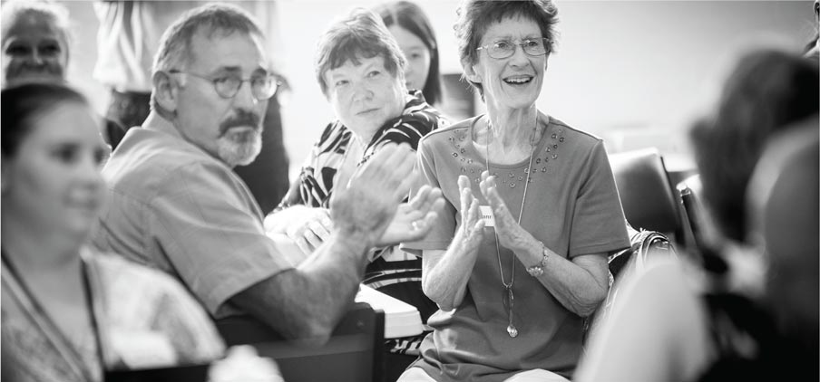
Community consultation, Whittlesea
Consistent with the ethos of the inquiry so far, the Commission will continue to involve people with lived experience in its work and in developing the final report. It will base its redesign of the mental health system on the needs of people with lived experience.
In designing a future mental health system, the Commission will be guided by a set of principles that reflect the Commission’s current aspirations—importantly, where the inherent dignity of people living with mental illness is respected, and the necessary support is provided to enable people’s full and effective participation in society.
The Commission will design the central components of a future mental health system that is responsive, accessible and equitable. The future system must also be capable of responding to changing needs and capturing the contemporary opportunities of human-centred design and digital and technological transformation.
The Royal Commission’s final report will be delivered by 31 October 2020. It will set out an ambitious blueprint for transforming Victoria’s mental health system and improving the lives of people experiencing mental illness, their families and carers and the Victorian community now and in the future.

Endnotes for Summary

Recommendations

Victorian Collaborative Centre for Mental Health and Wellbeing

Recommendation 1
The Royal Commission recommends that the Victorian Government establishes a new entity, the Victorian Collaborative Centre for Mental Health and Wellbeing. As a first step, the Mental Health Implementation Office should establish the governance of the Collaborative Centre and begin planning for a purpose-built facility in Melbourne.
The Collaborative Centre will bring people with lived experience together with researchers and experts in multidisciplinary clinical and non-clinical care to develop and provide adult mental health services, conduct research and disseminate knowledge with the aim of delivering the best possible outcomes for people living with mental illness. The centre will work within a network of partners including service and research organisations in rural and regional areas.
The Collaborative Centre will:
- drive exemplary practice for the full and effective participation and inclusion of people with lived experience across the mental health system
- conduct interdisciplinary, translational research into new treatments and models of care and support to inform service delivery, policy and law making
- educate the mental health workforce through practice improvement, training and professional development programs.
Models of care for the services the Collaborative Centre provides to its local community will reflect the Commission’s final redesign of Victoria’s mental health system.

Targeted acute mental health service expansion

Recommendation 2
The Royal Commission recommends that the Victorian Government, through the Victorian Health and Human Services Building Authority and the Mental Health Implementation Office, provides funding for 170 additional youth and adult acute mental health beds to help address critical demand pressures. The allocation should be as follows:
- 135 additional acute inpatient public mental health beds or equivalent beds, with the majority of these delivered by the end of 2021 and the remainder by mid-2022, proportionally provided to Barwon Health and to Melbourne Health, the latter in alliance with Western Health and Northern Health, using the following criteria: predicted population growth, forecast bed availability, socio-economic need and the availability of primary and community-based health services
- 35 additional acute inpatient mental health beds or equivalent beds procured by the end of 2021 from a private provider to deliver clinical treatment, care and support for public patients who would otherwise be treated in a public inpatient mental health unit.
The design and establishment of the additional beds should:
- be contemporary, co-designed with people with lived experience, and provide high-quality care in a hospital setting
- involve public, private and community health service partnerships.
Assertive outreach should be used to enable acute care in a home or community residence, where possible, as a direct substitute for an inpatient bed.

Suicide prevention

Recommendation 3
The Royal Commission recommends that the Victorian Government, through the Mental Health Implementation Office, expands follow-up care and support for people after a suicide attempt by recurrently funding all area mental health services to offer the Hospital Outreach Post-suicidal after Engagement (HOPE) program. To facilitate access to HOPE, the statewide rollout should be complemented by:
- broad referral pathways to give people living with mental illness who are receiving care from clinical community-based teams within area mental health services access to HOPE
- additional clinical outreach services in each sub-regional health service, networked to a regional health service HOPE program, to provide support for people living in rural and regional areas
- extended service delivery that allows access to support whenever it is needed, including outside standard business hours.
The Commission also recommends the creation, delivery and evaluation of the first phase of a new assertive outreach and follow-up care service for children and young people who have self-harmed or who are at risk of suicide.

Aboriginal social and emotional wellbeing

Recommendation 4
The Royal Commission recommends that the Victorian Government, through the Mental Health Implementation Office, expands social and emotional wellbeing teams throughout Victoria and that these teams be supported by a new Aboriginal Social and Emotional Wellbeing Centre. This should be facilitated through the following mechanisms:
- dedicated recurrent funding to establish and expand multidisciplinary social and emotional wellbeing teams in Aboriginal Community Controlled Health Organisations, with statewide coverage within five years
- scholarships to enable Aboriginal social and emotional wellbeing team members to obtain recognised clinical mental health qualifications from approved public tertiary providers, with a minimum of 30 scholarships awarded over the next five years
- recurrent funding for the Victorian Aboriginal Community Controlled Health Organisation to develop, host and maintain the recommended Aboriginal Social and Emotional Wellbeing Centre in partnership with organisations with clinical expertise and research expertise in Aboriginal mental health. The centre will help expand social and emotional wellbeing services through:
  - clinical, organisational and cultural governance planning and development
  - workforce development—including by enabling the recommended scholarships
  - guidance, tools and practical supports for building clinical effectiveness in assessment, diagnosis and treatment
  - developing and disseminating research and evidence for social and emotional wellbeing models and convening associated communities of practice.

A service designed and delivered by people with lived experience

Recommendation 5
The Royal Commission recommends that the Victorian Government establishes Victoria’s first residential mental health service designed and delivered by people with lived experience. This should be facilitated through the Mental Health Implementation Office in co-production with people with lived experience.
This service should provide short-term treatment, care and support in a residential community setting as an alternative to acute hospital-based care, and be:
- delivered and operationally managed by a workforce comprising a majority of people with lived experience, working across a range of disciplines
- facilitated through a partnership between an area mental health service and a mental health community support service or a community health service
- independently evaluated, with findings to inform continuous improvement and guide the expansion of similar services.

Lived experience workforces

Recommendation 6
The Royal Commission recommends that the Victorian Government, through the Mental Health Implementation Office, expands the consumer and family-carer lived experience workforces and enhances workplace supports for their practice. This program of work should be co-produced with people with lived experience and representatives of lived experience workforces and be implemented across area mental health services and identified non-government organisations comprising:
- the development and implementation of continuing learning and development pathways, educational and training opportunities and optional qualifications for lived experience workers, including adding the Certificate IV in Mental Health Peer Work to the free TAFE course list
- new organisational structures, capability and programs within services to enable practice supports, including coaching and supervision for lived experience workers
- delivery of a mandatory, organisational readiness and training program for senior leaders, and induction materials for new staff, that focus on building shared understanding of the value and expertise of lived experience workers
- implementation of ongoing accountability mechanisms for measuring organisational attitudes and the experiences of lived experience workers, including establishing a benchmark in 2020 of the experience of lived experience workers.

Workforce readiness

Recommendation 7
The Royal Commission recommends that the Victorian Government, through the Mental Health Implementation Office, prepares for workforce reform and addresses workforce shortages by developing educational and training pathways and recruitment strategies by providing:
- public mental health services in areas of need, including in rural and regional locations, through an expression of interest process that each year offers a minimum of:
  - 60 new funded graduate placements for allied health and other professionals
  - 120 additional funded graduate placements for nurses
- postgraduate mental health nurse scholarships to 140 additional nurses each year that covers the full costs of study
- an agreed proportion of junior medical officers to undertake a psychiatry rotation, effective from 2021, with it being mandatory for all junior medical officers by 2023 or earlier
- overseas recruitment campaigns, including resources to assist mental health services to recruit internationally, new recruitment partnerships between organisations, and mentoring programs for new employees
- a ‘mental health leadership network’ with representation across the state and the various disciplines, including lived experience workforces, supported to participate collaboratively in new learning, training and mentorship opportunities
- the collation and publication of the profile of the mental health workforce across all geographic areas, disciplines, settings and sub-specialties
- mechanisms for continuing data collection and analysis of workforce gaps and projections, and the regular mapping of the workforce to meet these gaps.

New approach for mental health investment

Recommendation 8
The Royal Commission recommends that the Victorian Government designs and implements a new approach to mental health investment comprising:
- a new revenue mechanism (a levy or tax) for the provision of operational funding for mental health services
- a dedicated capital investment fund for the mental health system.
This new approach should support a substantial increase in investment in Victoria’s mental health system, supplementing the current level and future expected growth of the state’s existing funding commitments.

The Mental Health Implementation Office

Recommendation 9
The Royal Commission recommends that the Victorian Government establishes a Mental Health Implementation Office—a new administrative office in relation to the Department of Health and Human Services under the Public Administration Act 2004 (Vic).
The Implementation Office is to implement the Commission’s recommendations as set out in the interim report. It will operate for two years while the Commission designs final governance arrangements for the mental health system and should:
- develop and publicly commit to a program of work and report annually through the Victorian Parliament on its progress against outcome measures and targets
- employ and commission people with specialist skills and diverse expertise, including people with lived experience, to respond to the Commission’s recommendations
- work closely with the Commission to ensure implementation of the Commission’s recommendations stay true to the original vision and intent.

RCVMHS, Dandenong Community Consultation – May 2019.
Commission analysis of National Mental Health Service Planning Framework, National Mental Health Service Planning Framework, January 2019.
Department of Health and Human Services, Victoria’s 10-Year Mental Health Plan, November 2015, p. 7.
Commission calculations based on the National Mental Health Service Planning Framework and population data from Department of Environment, Land, Water and Planning, Victoria in the Future, 2019. Australian Bureau of Statistics, Australian Demographic Statistics, June 1999 (Canberra); National Mental Health Strategy, National Mental Health Service Planning Framework Care Profiles – All Ages, August 2016. p. 92, 96, 102.
Coroners Court of Victoria. Suicide Data Summary, 2009 to 2018; Transport Accident Commission. Search statistics <http://www.tac.vic.gov.au/road-safety/statistics/online-crash-database/search-crash-data?> [accessed 27 October 2019].
Department of Health and Human Services, Integrated Data Resource, Victorian Emergency Minimum Dataset, 2017–18 and 2018–19.
RCVMHS, Bendigo Community Consultation – May 2019.
Australian Institute of Health and Welfare, Australian Burden of Disease Study: Impact and Causes of Illness and Death in Australia 2015. Australian Burden of Disease Series No. 19. Cat. No. BOD 22. Canberra: AIHW. Data Tables: 2015 National Estimates for Australia, 2019. Table 1B. Disease group and Table 1C. Disease.
James Bennett and Zalika Rizmal, ‘Mental Health Royal Commission’s Final Witness Optimistic System Can Be Rebuilt “with Some Humanity”‘, ABC News, 26 July 2019.
See Appendix C: Background to economic analysis (Section C.2) for details of the assumptions and data sources used.
Witness Statement of Professor Patrick McGorry AO, 2 July 2019, para. 21; Ronald C Kessler and others, ‘Lifetime prevalence and age-of-onset distributions of DSM-IV disorders in the National Comorbidity Survey replication’, Archives of General Psychiatry, 62.6 (2005), 593-602 (p. 593).
Commission estimate. See Appendix C: Background to economic analysis (Section C.2) for details of the assumptions and data sources used.
Department of Health and Human Services, Balit Murrup: Aboriginal Social and Emotional Wellbeing Framework 2017–2027, October 2017, p. 10; Working Together: Aboriginal and Torres Strait Islander Mental Health and Wellbeing Principles and Practice, ed. by P Dudgeon, H Milroy, and R Walker (Canberra: Commonwealth of Australia, 2014), p. 3.
Witness Statement of Aunty Nellie Flagg, 4 July 2019. Evidence of Aunty Nellie Flagg, pp. 1039-1046

